**Introduction**  
**AVL Tree** => **Height Balanced Binary Search Tree**  
  
* Invented by mathematicians in 1962.  
* We get different binary search trees with the same set of data if the sequence of insertions is different.  
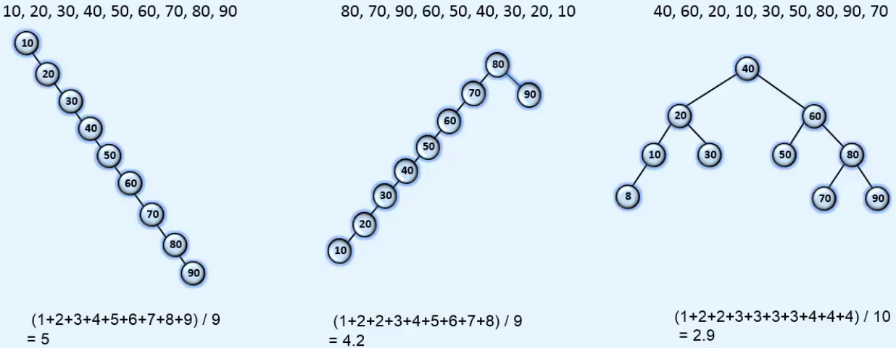  
* The average number of comparisons to reach a node - under the graphs.  
* **Searching in a balanced tree is better**.  
* In a BST, **searching** is **O(h)** **where h is height of Binary Tree**.  
* The first tree is just a form of a linear list.  
* **Difference in the height of left and right subtrees if any node <= 1**.  
* This is an AVL Tree: * This is NOT an AVL Tree:  
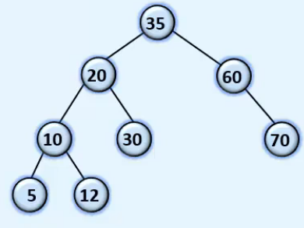 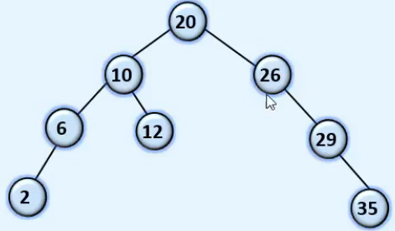  
* In AVL Tree we define a Balance Factor for each node.  
**Balance Factor of a node** = **height of its left subtree - height of its right subtree**.  
* In AVL Trees there are 3 valid values: -1, 0, 1  
**Left** **Heavy** => **1** => **height of left subtree > height of right subtree**.  
**Right** **Heavy** => **-1** => **height of right subtree > height of left subtree**.   
**Balanced** => **0** => **height of right subtree = height of left subtree**.  
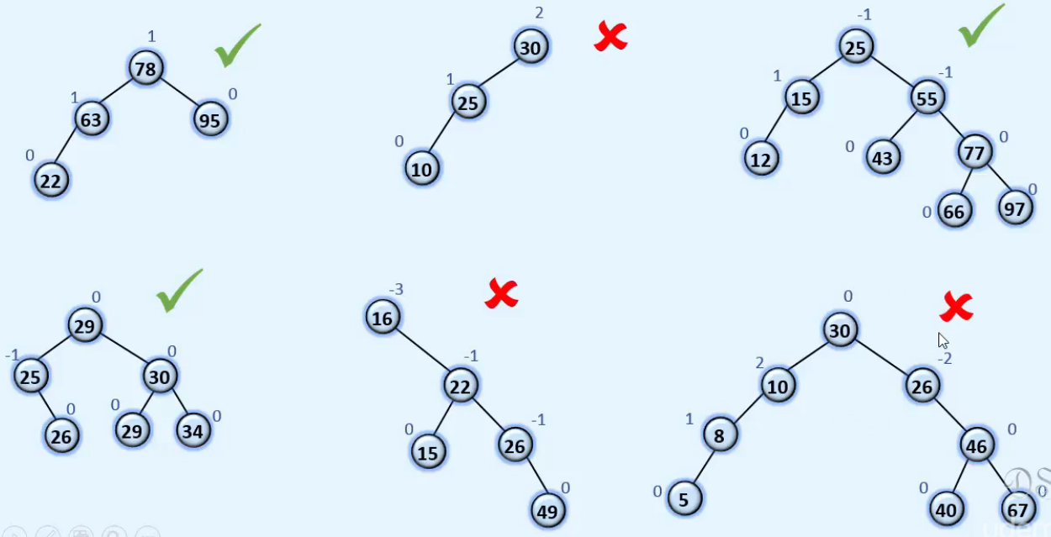

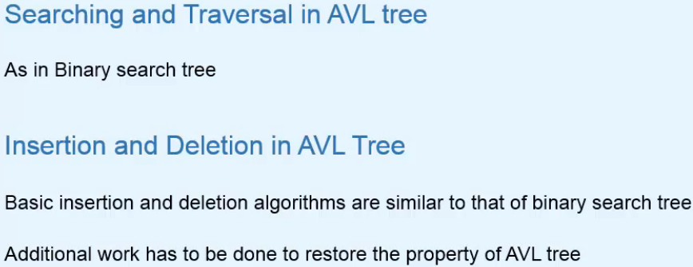

* **Searching and Traversal is the same as in BST**.

* **Insertion and Deletion is the same as in BST but if the AVL Tree property is violated, we need to restore it by balancing the tree**.  
=> **Tree** **Rotations**.

**Rotations**  
* **Rotations in a Binary Search Tree**.  
* When a balanced tree becomes unbalanced after insertion/deletion operations, these rotations are used to balance the tree.  
=> **Rotations rearranged some nodes of the tree**.  
=> **Binary Search Tree property is retained**.  
=> **Inorder traversal remains the same**.  
**Right Rotation**  
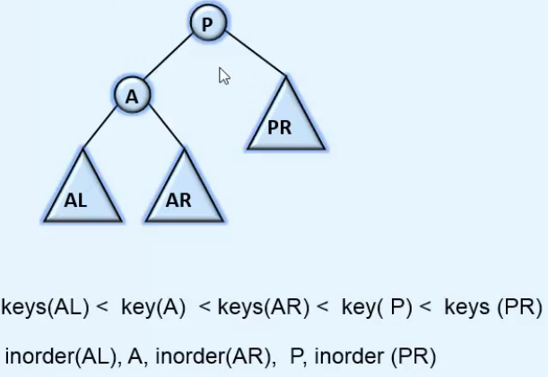  
=> P comes down.  
=> A goes up where P was and becomes the new root.  
=> P becomes the RIGHT child of A.  
=> RIGHT of A becomes LEFT of P.  
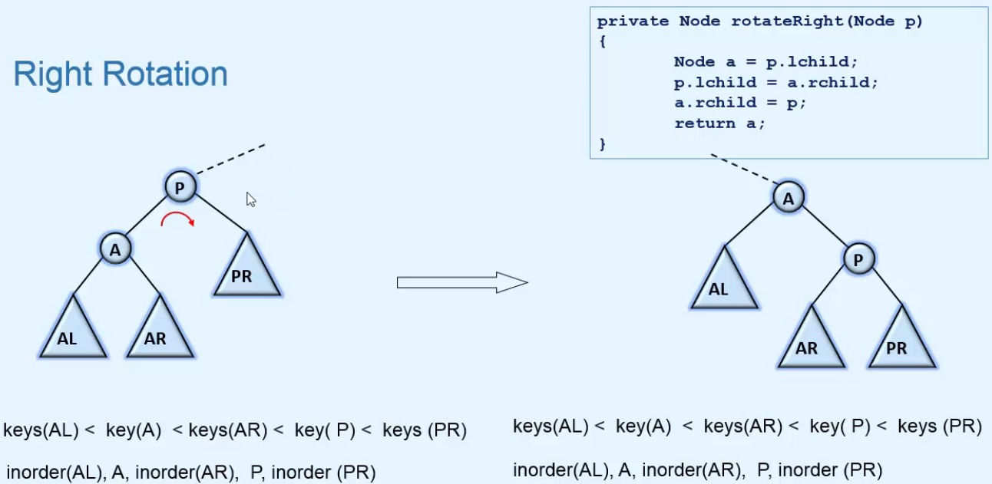  
=> **This tree could be a BST or a subtree of any node of a BST**.

* **Examples of right rotations**:  
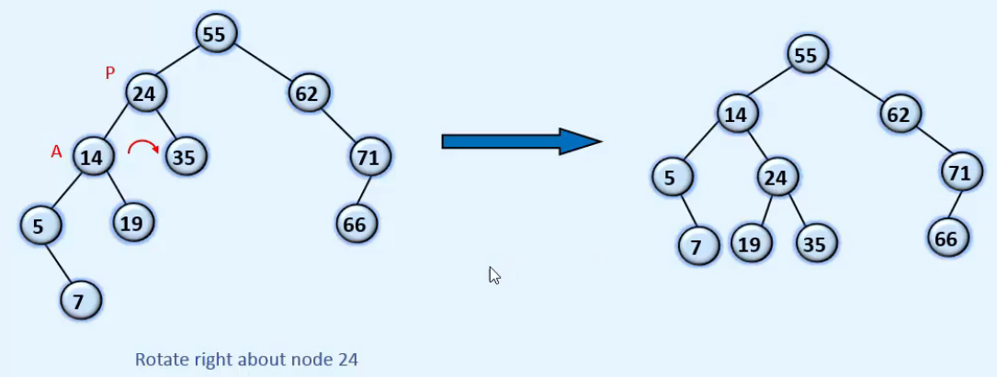  
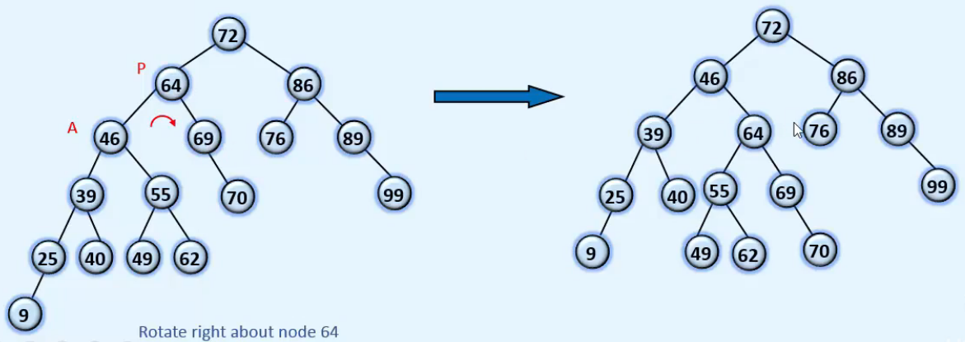  
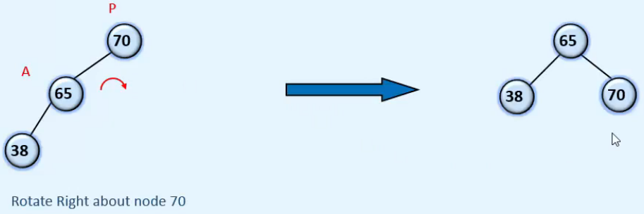  
**Left Rotation**  
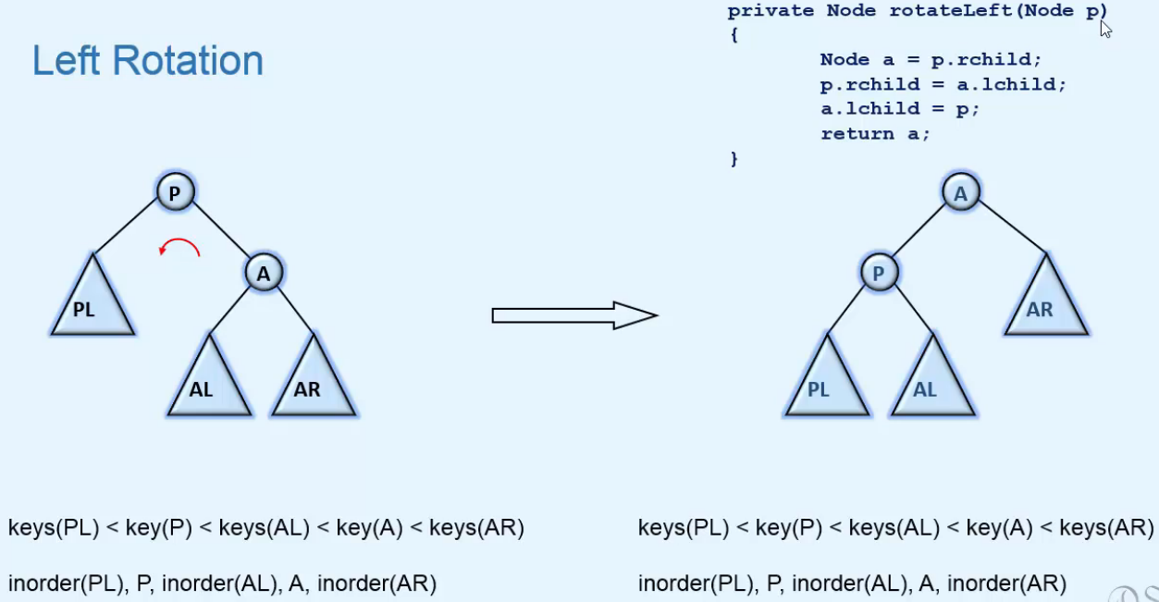  
* **Examples of left rotations**: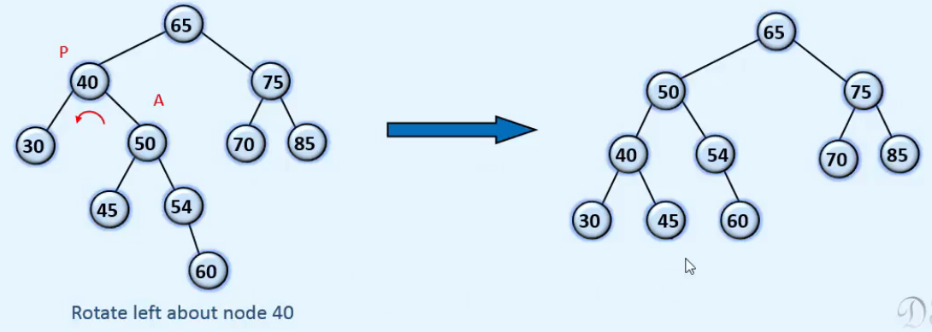  
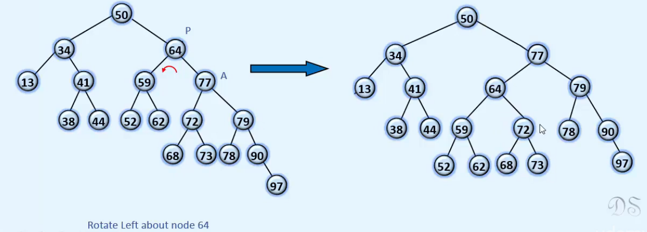  
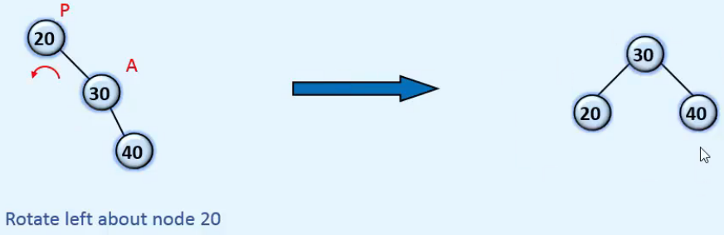

**Insertion in AVL tree - 1**  
* **Basic insertion algorithm is similar to that of BST**.  
* **Balance factors of some nodes of the tree will change**.  
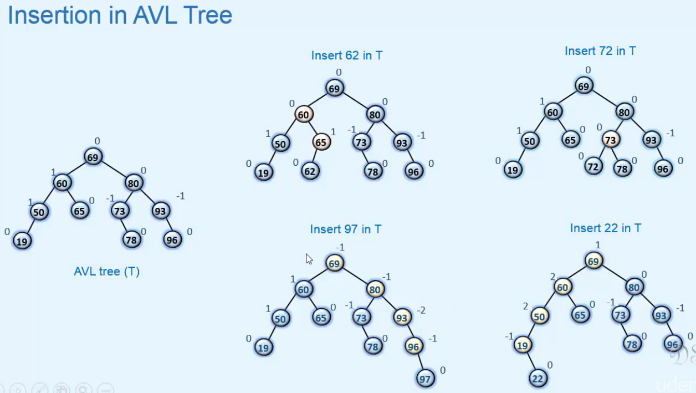  
=> **We can see that Balance Factors of only the ancestors of the newly inserted node can change**.  
=> **Only the nodes that are in the path from the new node to the root can be affected**.  
=> **Not all ancestors have to be affected**.  
* **Valid Balance Factors are 1 0 -1**  
=> If any Balance Factors has become invalid, AVL property is violated.  
* These 2 have violated balance factors:  
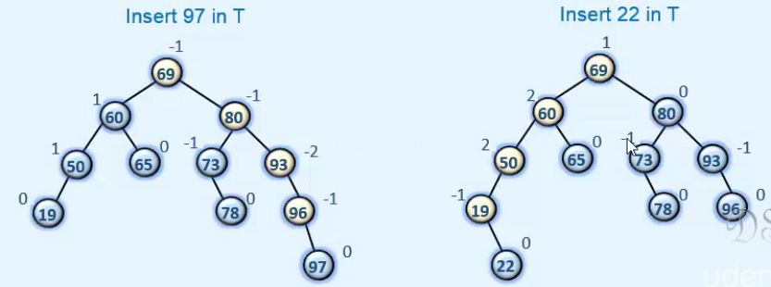  
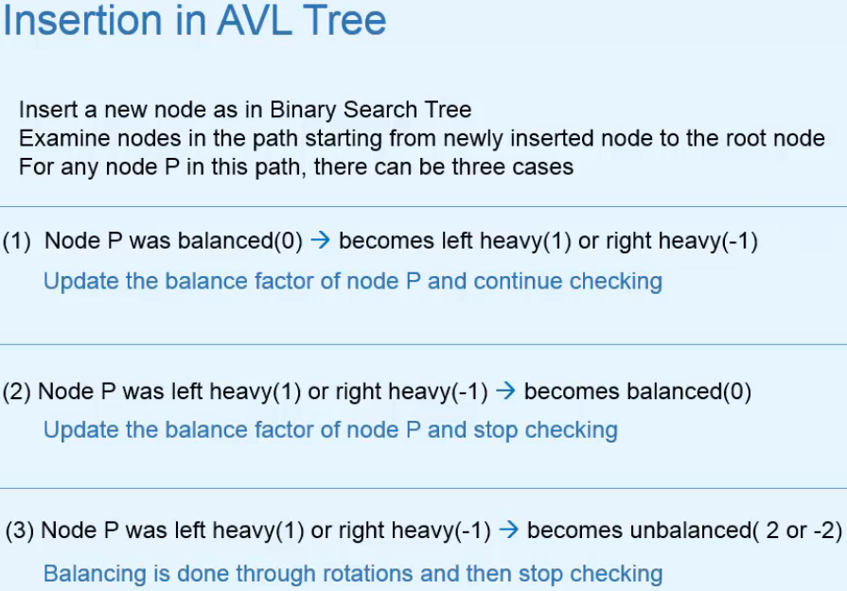

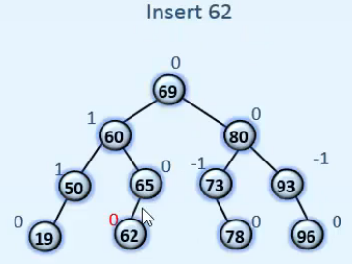 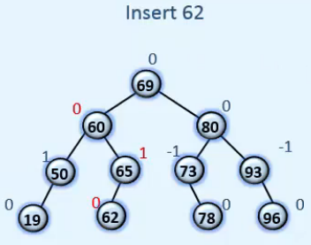

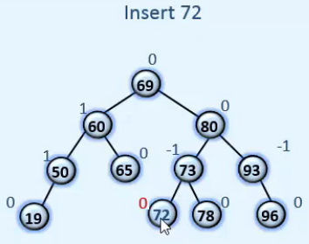 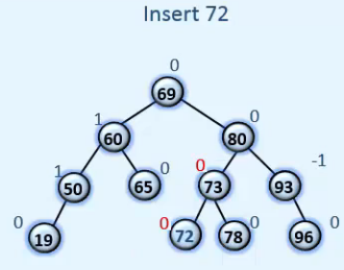

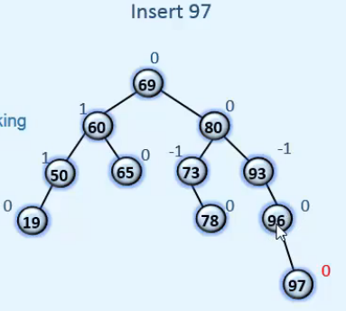 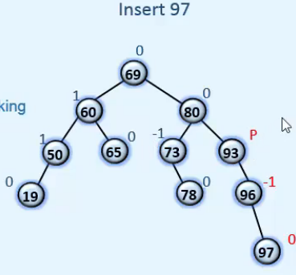  
=> This would become unbalanced, so we mark it as a Pivot node.  
=> We perform balancing about the node P.

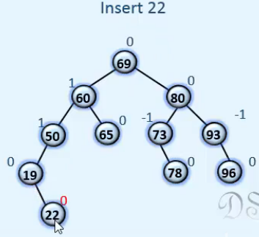 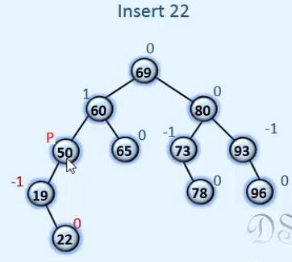

* **In each of the 3 cases we have 2 symetric cases depending on whether the insertion is done in the left subtree or in the right subtree**.  
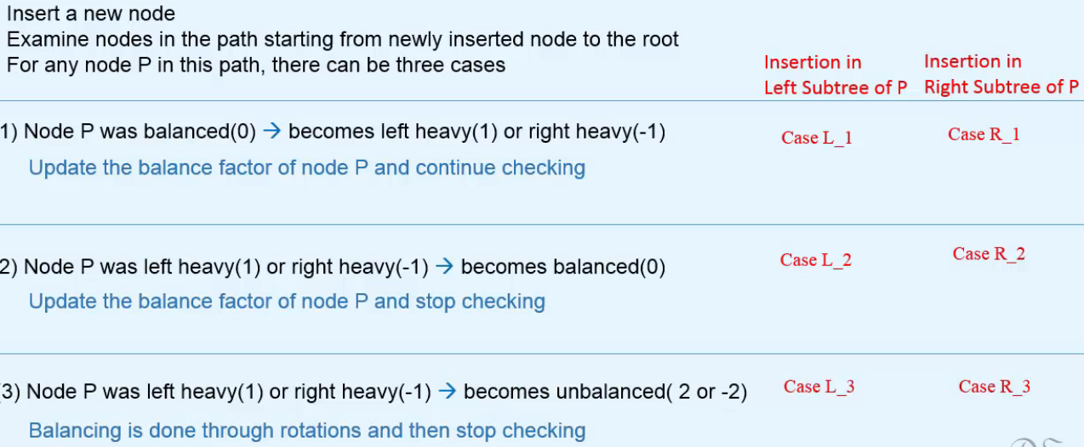

**Insertion in AVL tree - 2**  
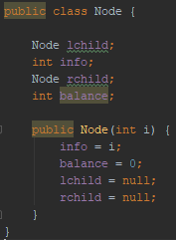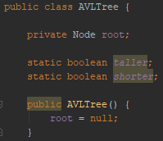 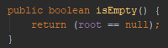  
* **The two static members will be used in the insertion and deletion methods**.  
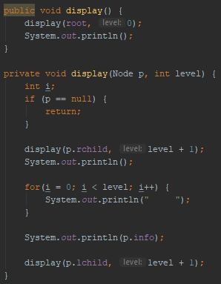 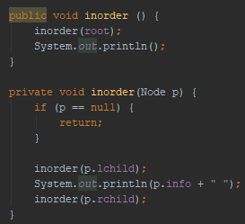  
  
  
  
  
  
  
* **The checks are done on the way up from the recursion - in the unwinding phase**.  
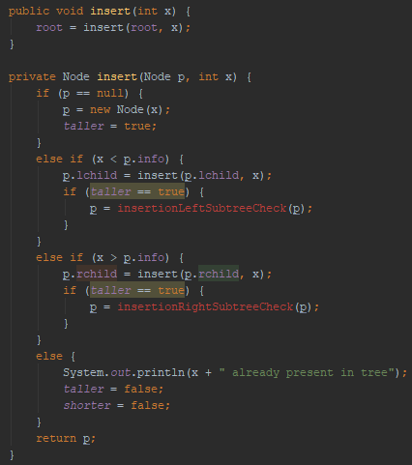  
* **When taller = false, then the CHECK method won’t be called in the remaining unwinding phase.**  
* **The process of checking of Balance Factor stops when taller = false**.  
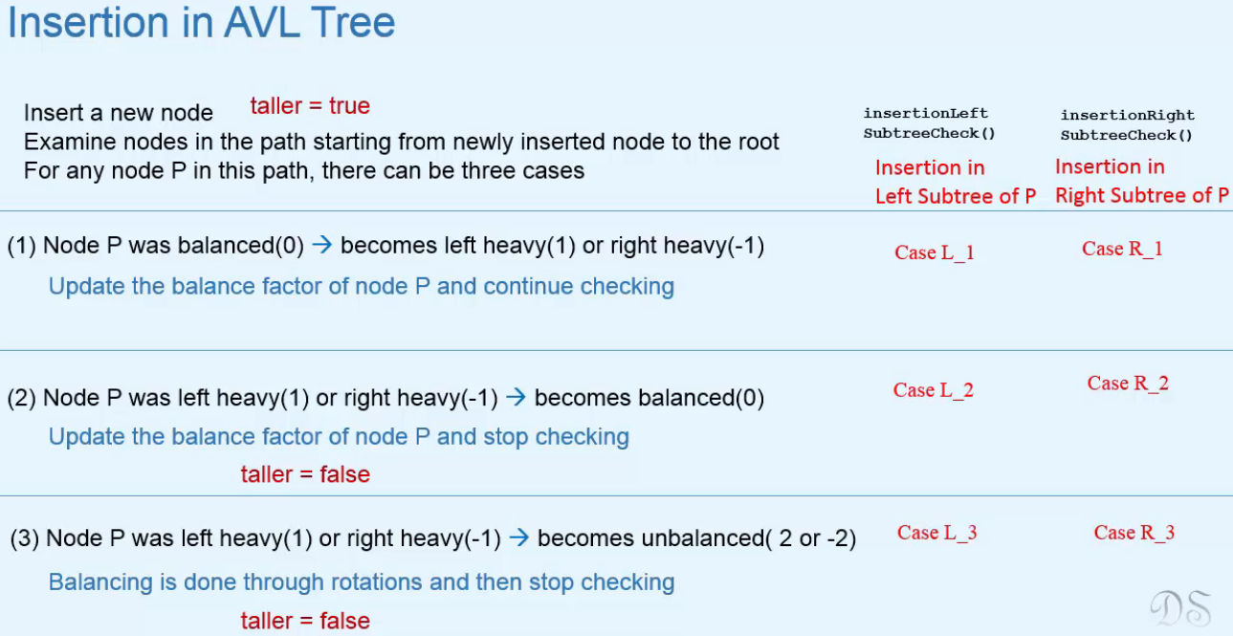

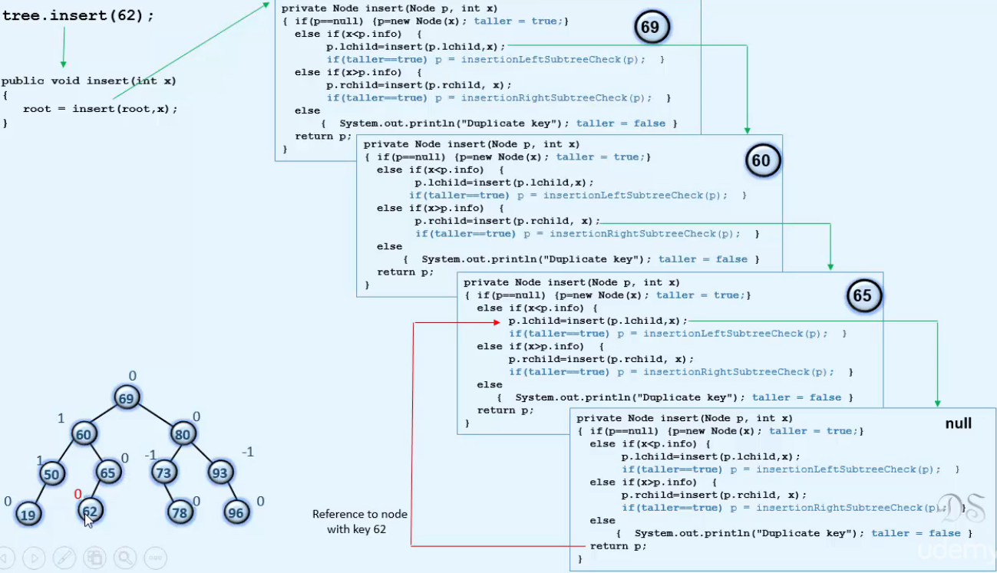  
=> We create 62 in the last call and then in the call above 62 becomes left child of 65.  
=> **taller = true and there can be one of L1 L2 L3 cases**.   
=> **If L2 or L3 is the case, we have to stop checking for Balance Factors so we make taller = false**.  
=> **In our case we have L1 - 65 was balanced, now becomes Left Heavy so 1 and we keep checking**.  
=> Then we go up to Node 60.  
=> **We have case R2 - 60 was Left Heavy (1) and now becomes Balanced (0), we set taller = false.**  
* Now the CHECKS won’t be called in the remaining calls.  
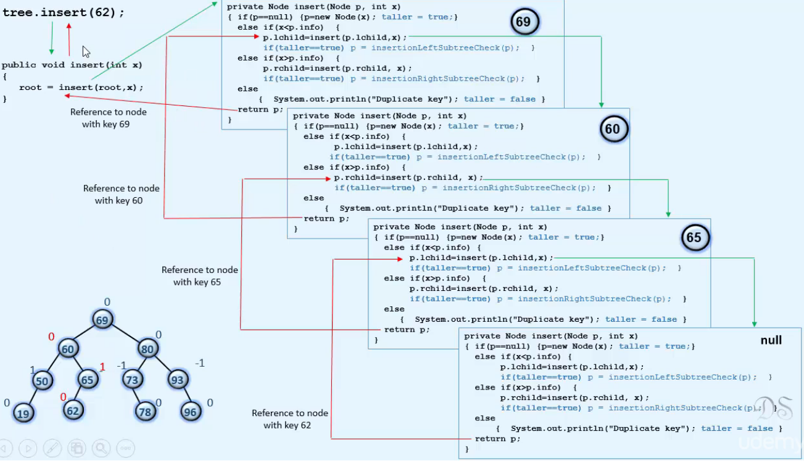

* **So now we know how we check Balance Factors in the unwinding phase and why we need the taller variable**.

**Insertion in AVL tree - 3**  
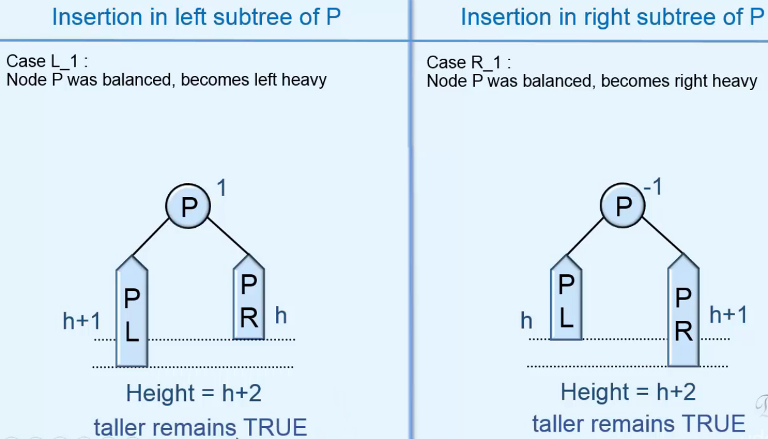  
* So we can see that in L1 and R1 the **height** of the subtree rooted **at P has increased after insertion**.  
* It was h + 1 before insertion and is now h + 2.  
=> And so the Balance Factor of this parent of P will change and that’s why we need to check the Balance Factor of the parent Node.  
=> We continue checking.  
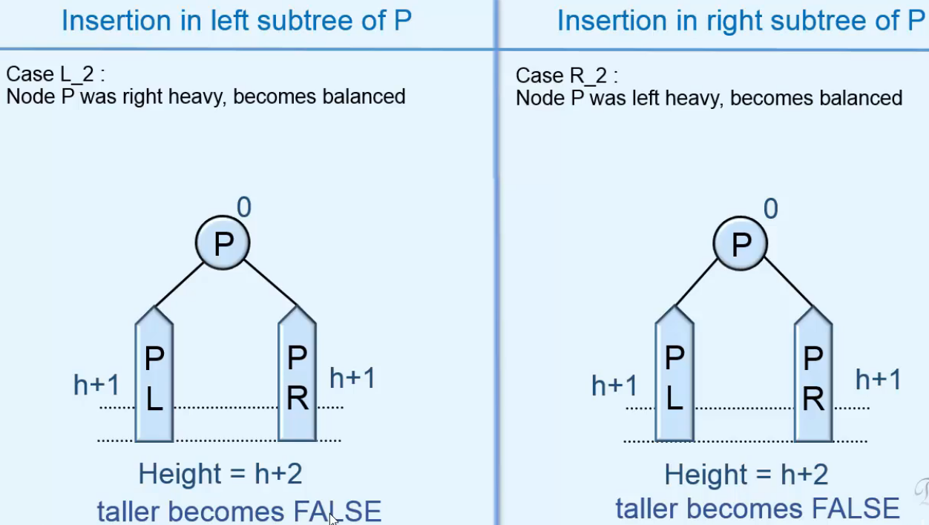  
* So we can see that in L2 and R2 the **height** of the subtree rooted **at P doesn’t change**.  
=> And so the Balance Factors of the ancestors will remain unchanged.  
=> We stop checking.

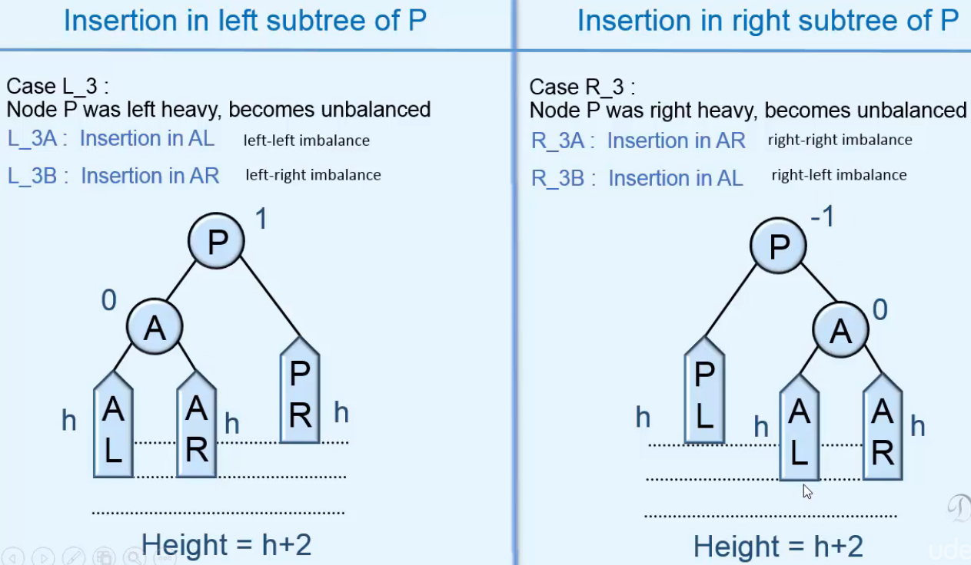  
=> **We call this Node as Pivot node and we balance the tree**.  
=> Balancing by performing Rotations at this Pivot Node.  
=> Balancing is done in such a way that the height of the subtree, rooted at Pivot Node, is same before/after insertion.  
=> So Balance Factors of ancestors will not change.  
=> We stop checking.

=> **We have 2 cases depending on if Insertion is done in left subtree of A or right subtree of A**.

**L_3A**: **LEFT subtree of LEFT child of P** => **1 rotation left-left imbalance**  
**R_3A**: **RIGHT subtree of RIGHT child of P** => **1 rotation right-right imbalance**

**L_3B**: **RIGHT subtree of LEFT child of P** => **2 rotations left-right imbalance**  
**R_3B**: **LEFT subtree of RIGHT child of P** => **2 rotations right-left imbalance**

* **Let’s look at LEFT-LEFT => L_3A**:  
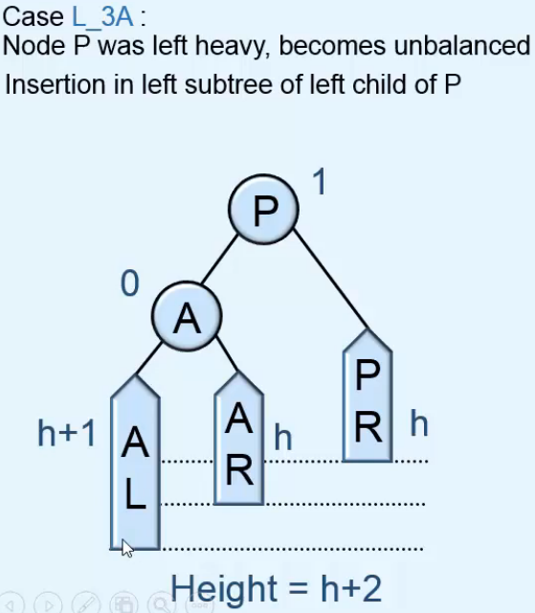 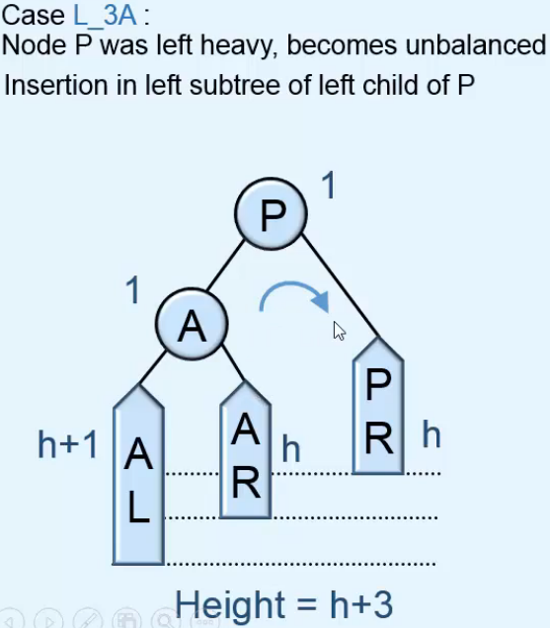

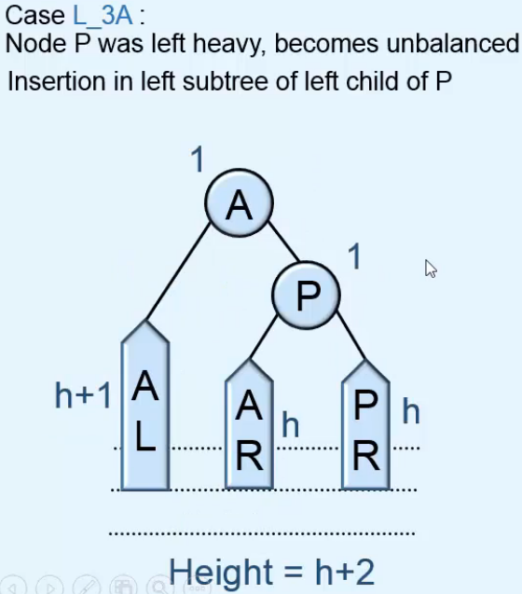 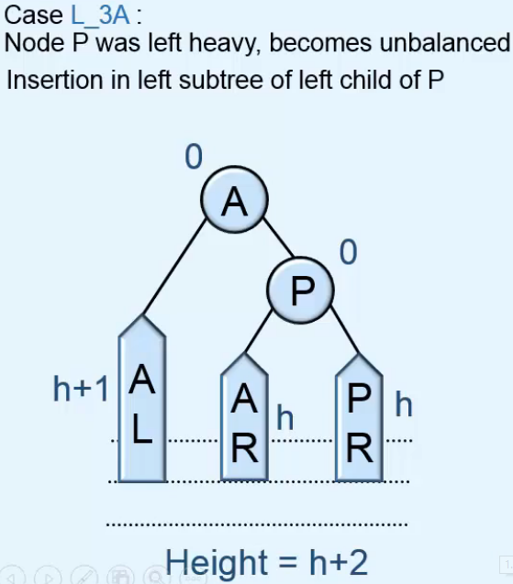  
* **Let’s look at RIGHT-RIGHT => R_3A**:  
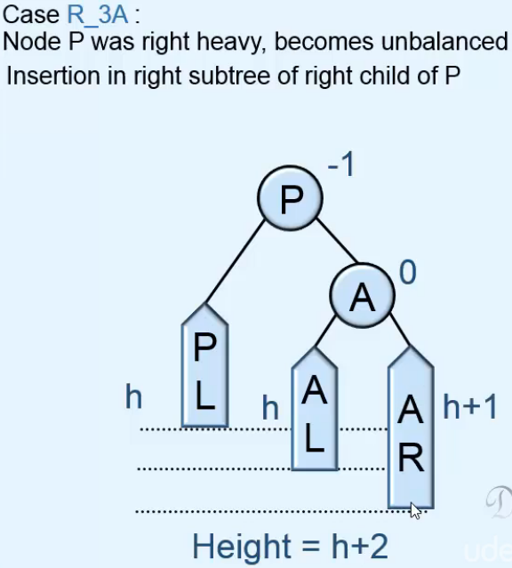 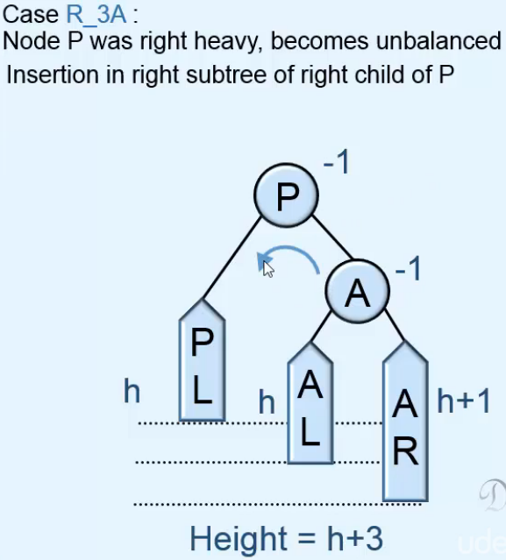

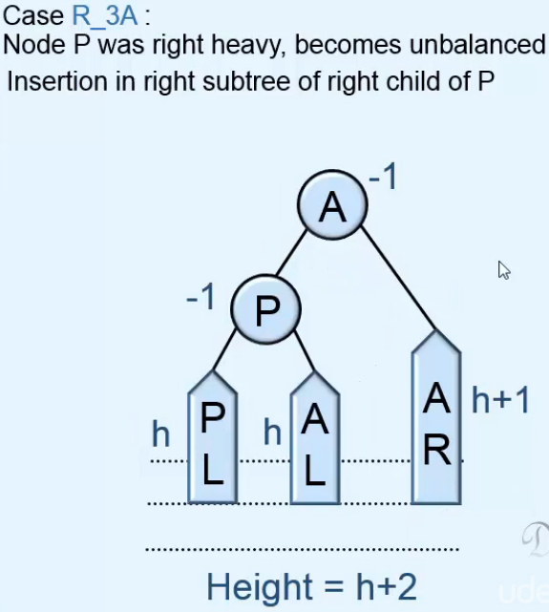 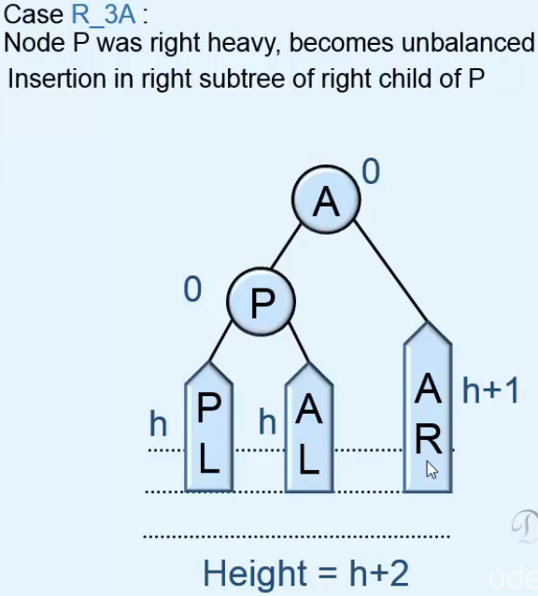

* **Let’s look at LEFT-RIGHT => L_3B**  
=> Rotate left about A.  
=> Rotate right about P.

* **Let’s look at RIGHT-LEFT => R_3B**  
=> Rotate right about A.  
=> Rotate left about P.

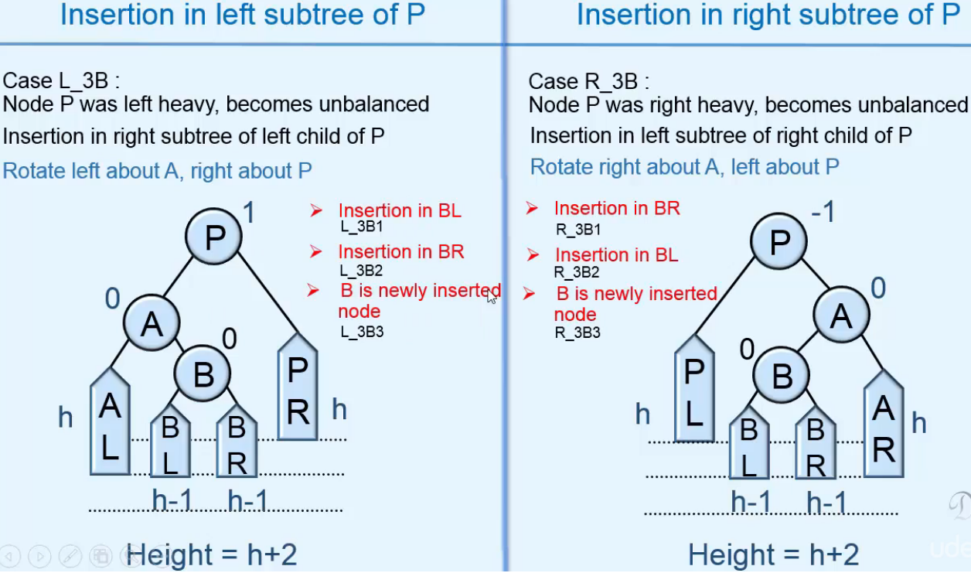  
=> Rotation performance is the same in all the 3 subcases, we’ve made these 3 cases because the resulting balance factor of nodes P and A will be different in the 3 cases.  
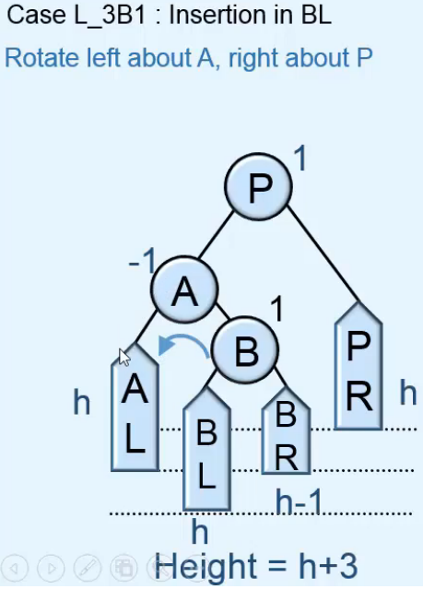 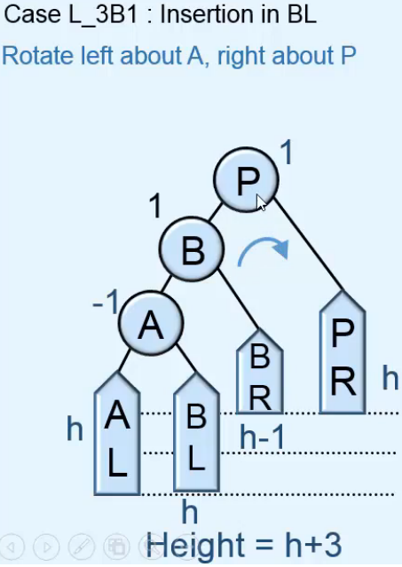 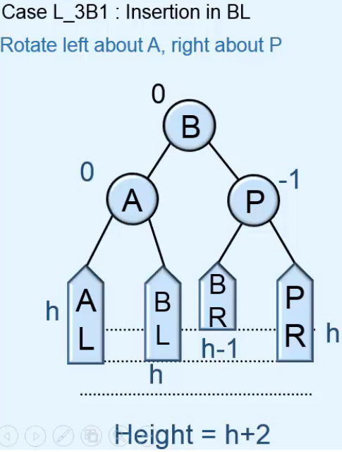

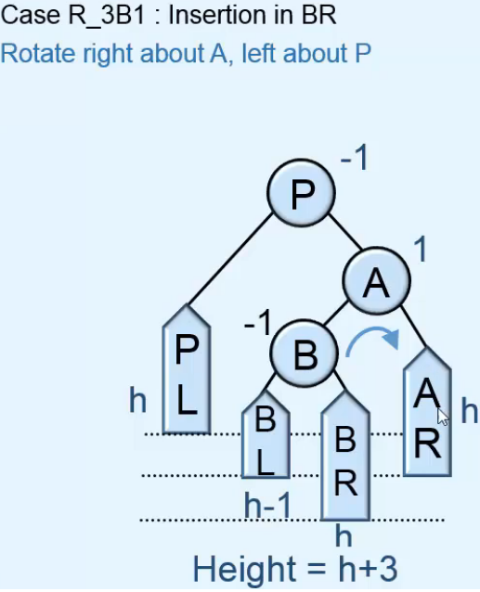 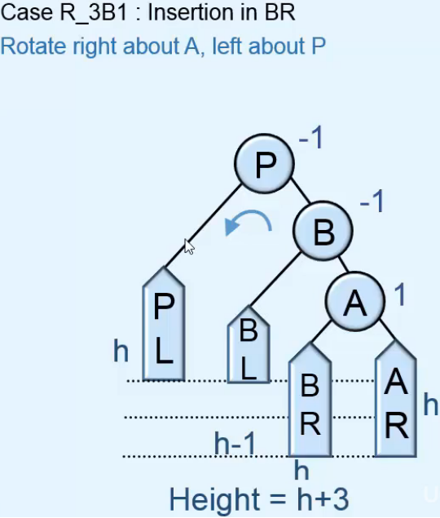 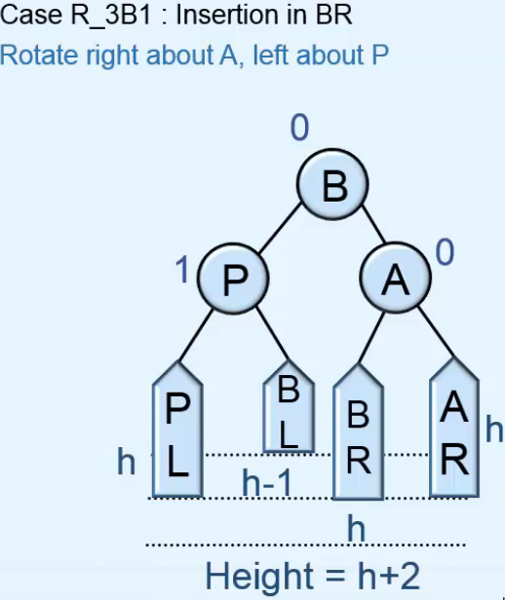

* **For L_3B2 / R_3B2 and L_3B3 / R_3B3, the rotation performance will be similar, the only difference will be in the resulting balance factors of node P and A**.

* **Subcase 2**  
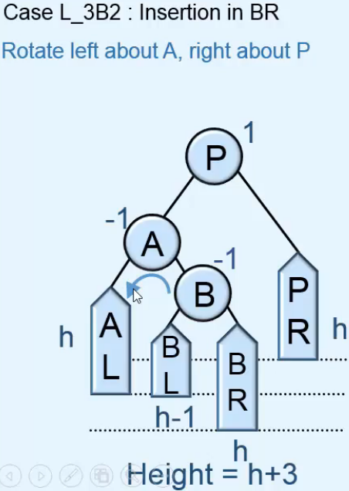 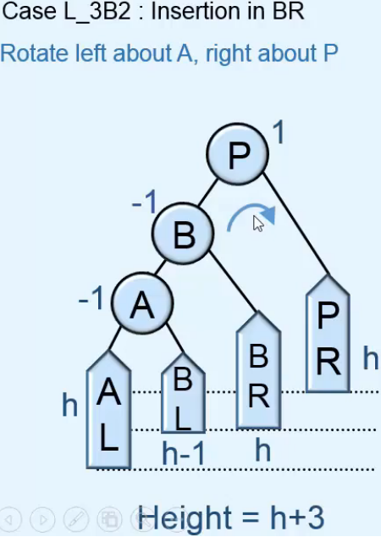 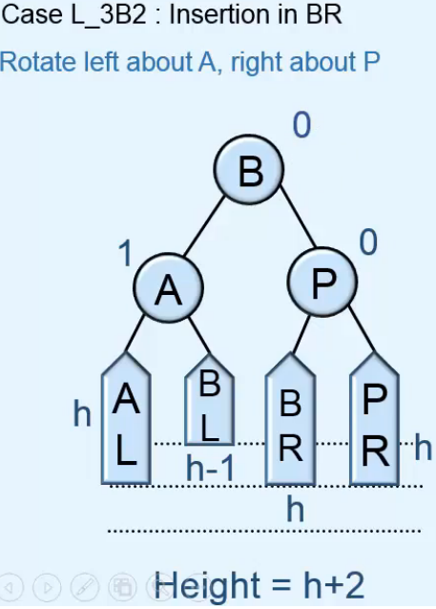

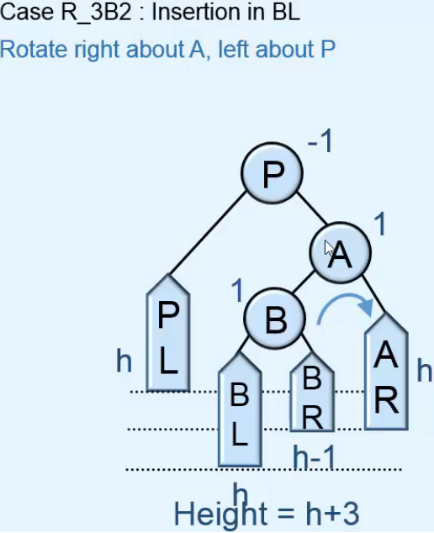 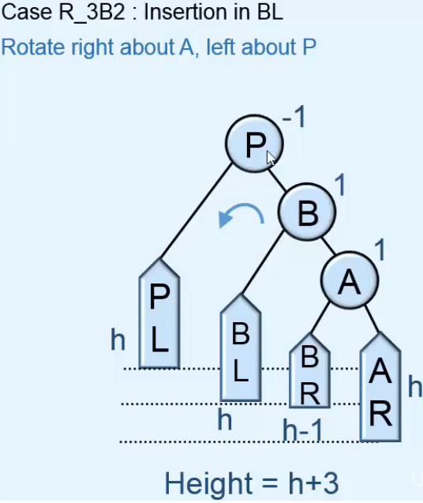 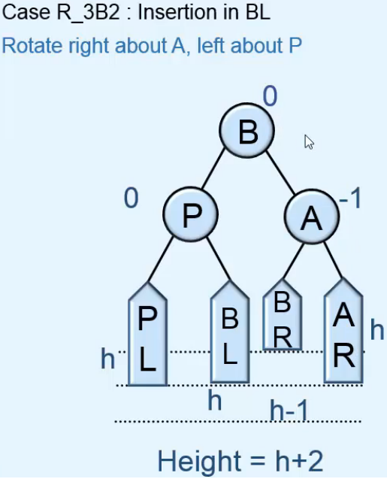

* **Subcase 3**  
* **Before insertion, A is balanced so its LEFT subtree will also be empty since the RIGHT subtree is empty**.  
* **h is 0 and so the RIGHT subtree of P will also be empty**.  
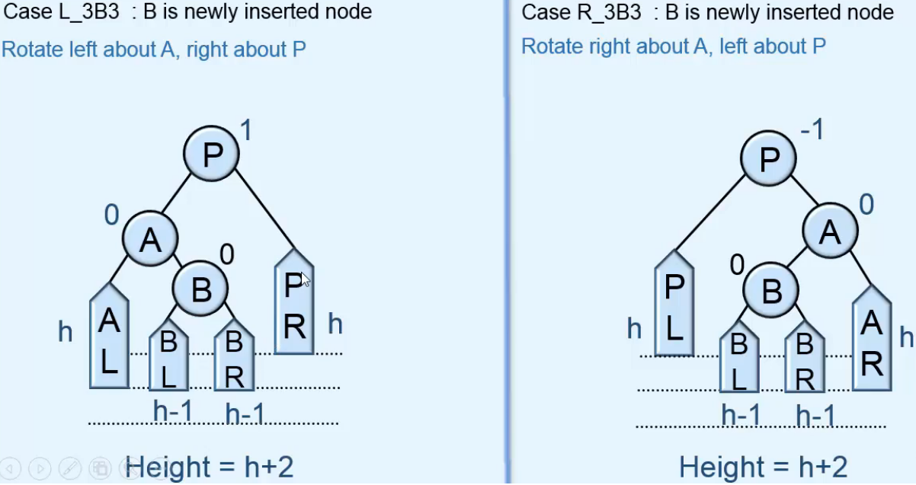  
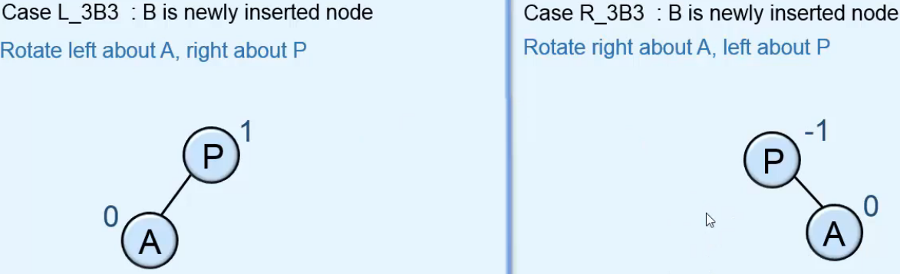  
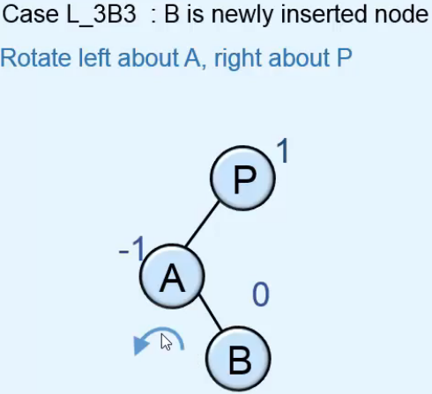 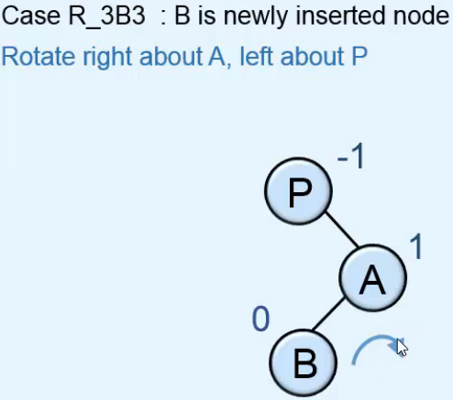  
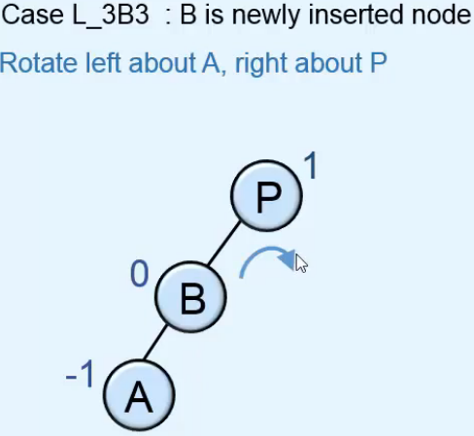 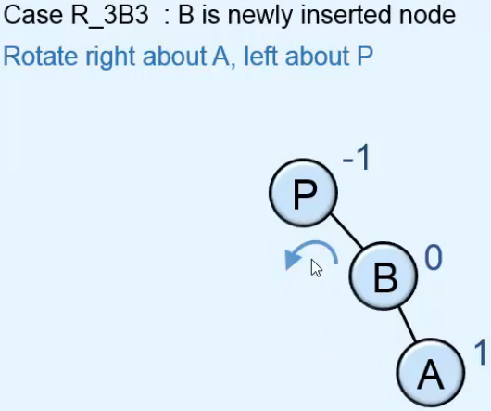  
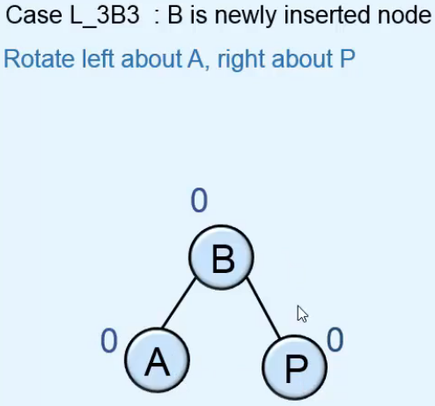 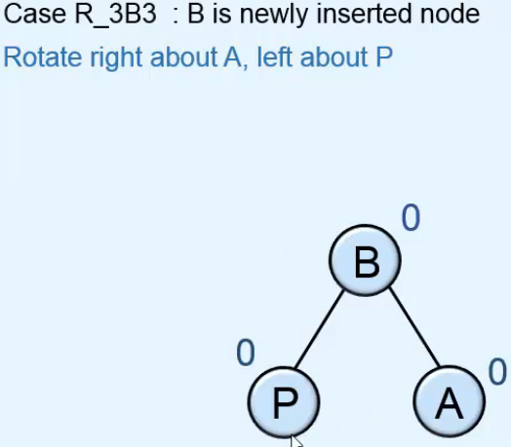

**Insertion in AVL tree - 4**  
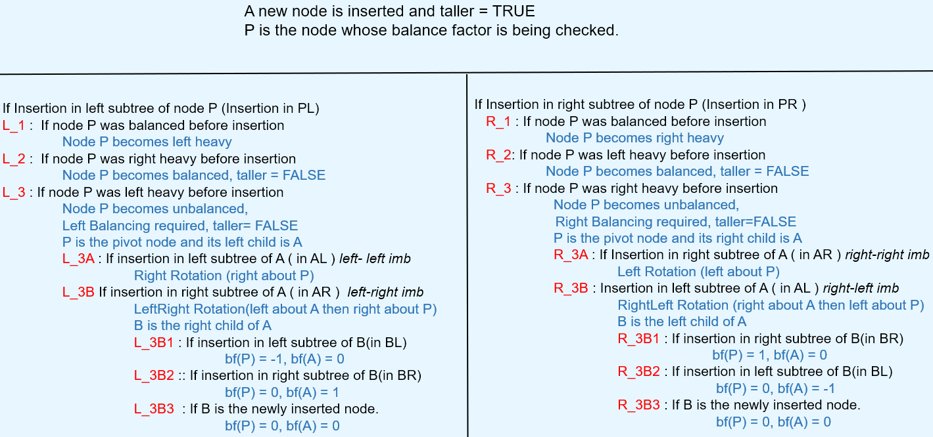  
* **L_3B first Rotation makes it L_3A case**.  
* **R_3B first Rotation makes it R_3A case**.  
* **The 3 subcases such as L_3B1, have the same rotations but the Balance Factors are different**.  
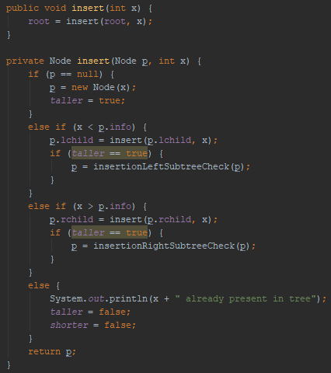 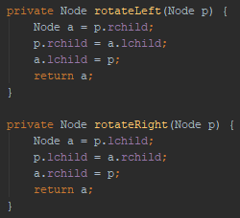

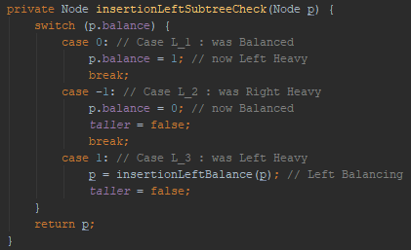 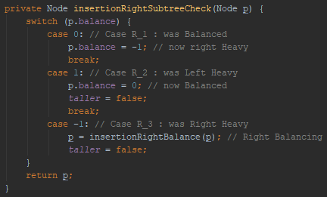

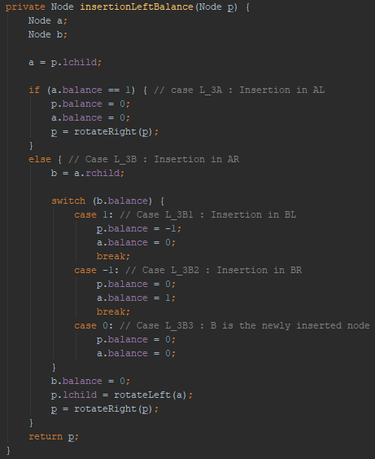 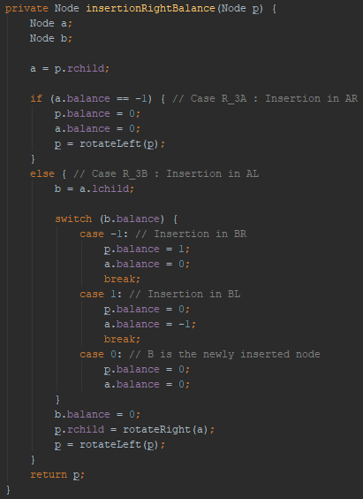

**Examples of insertion in AVL Tree**  
* **For performing insertions, we don’t need to remember all the cases and subcases**.  
* **We just need to remember these points**:  
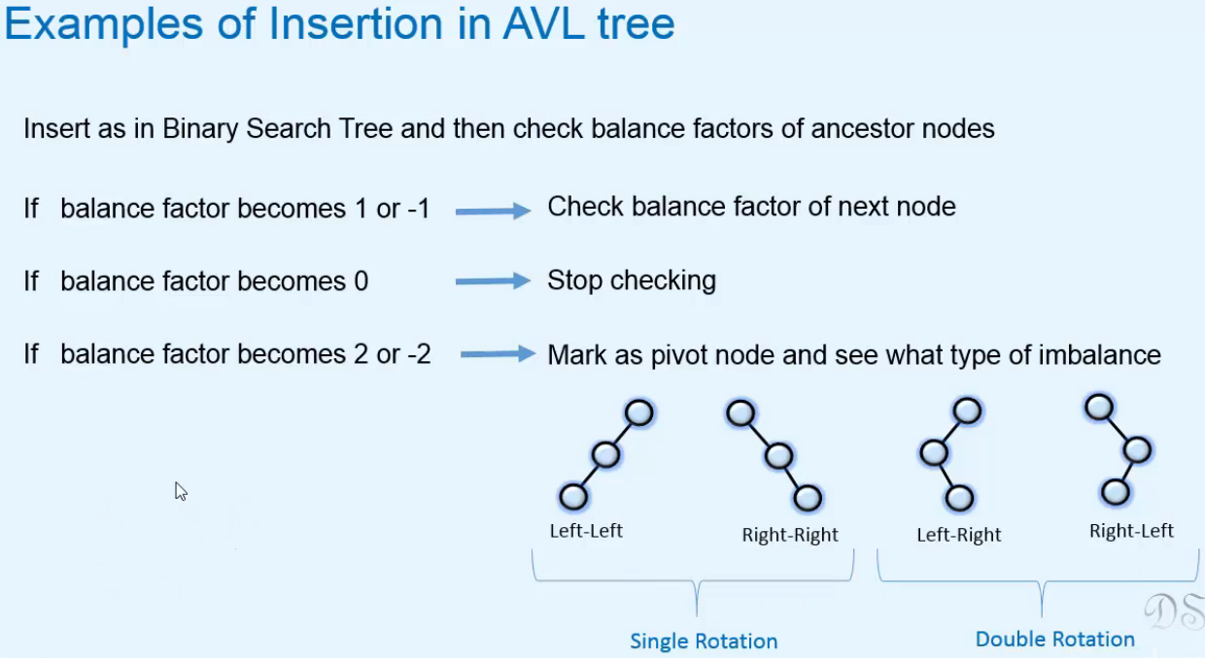  
<https://www.udemy.com/course/data-structures-and-algorithms-in-java-2/learn/lecture/4290318#announcements>

* **After inserting the values in this order**:  
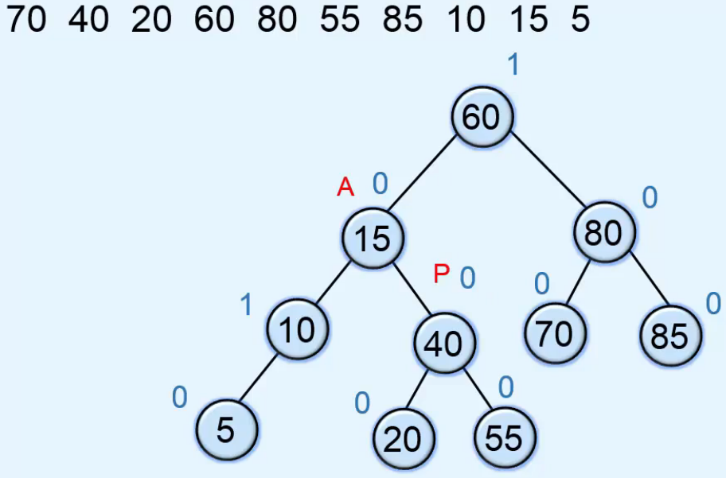

**Deletion in AVL Tree - 1**  
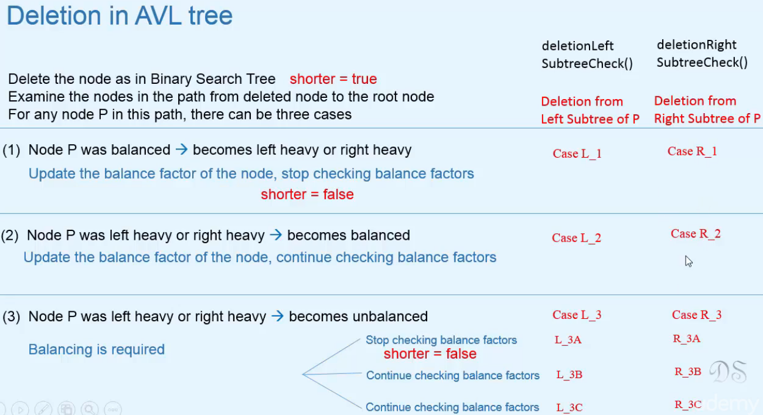  
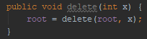

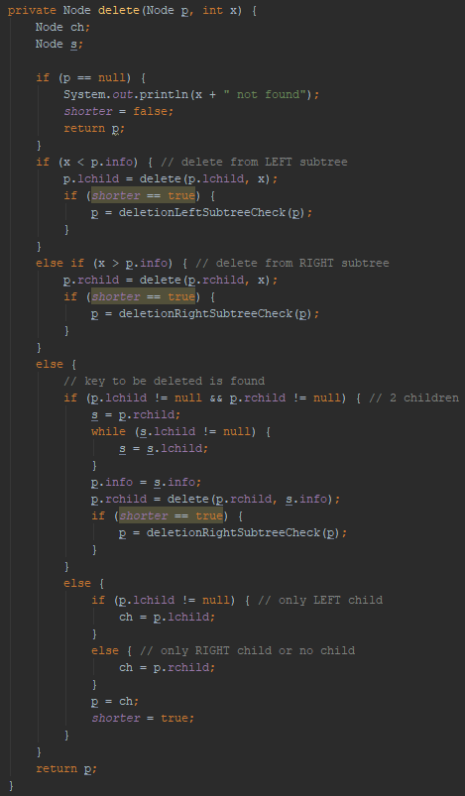 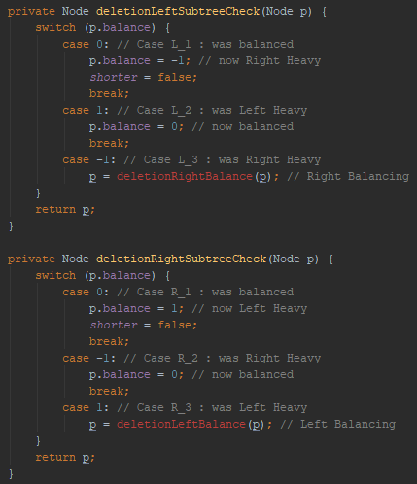

**Deletion in AVL Tree - 2**  
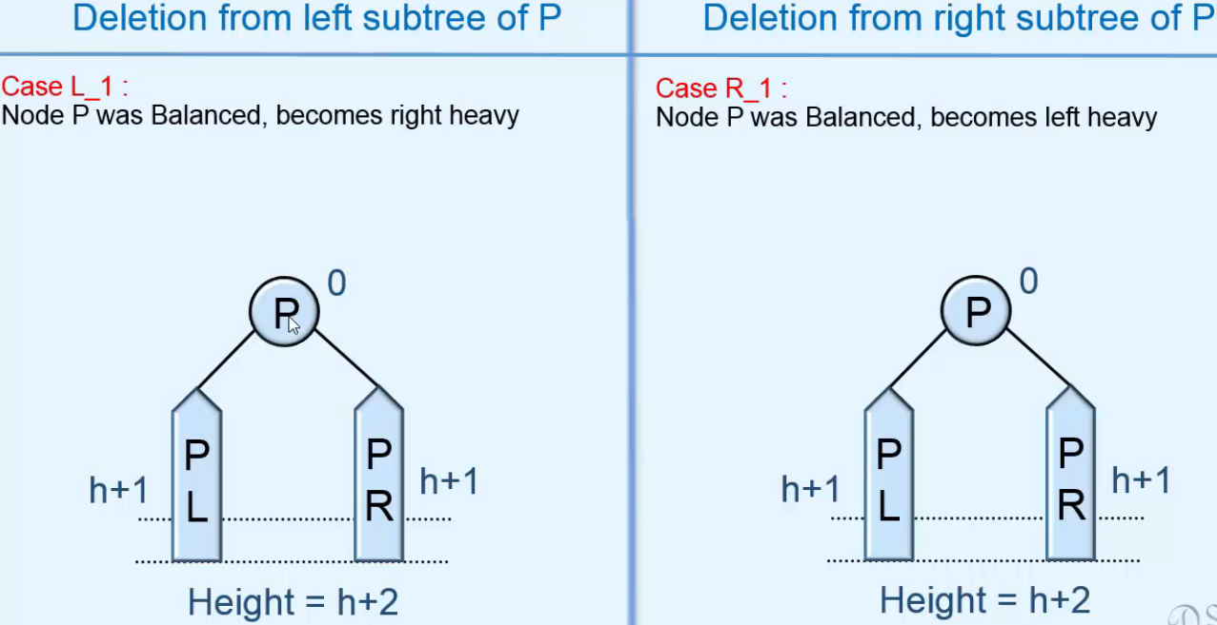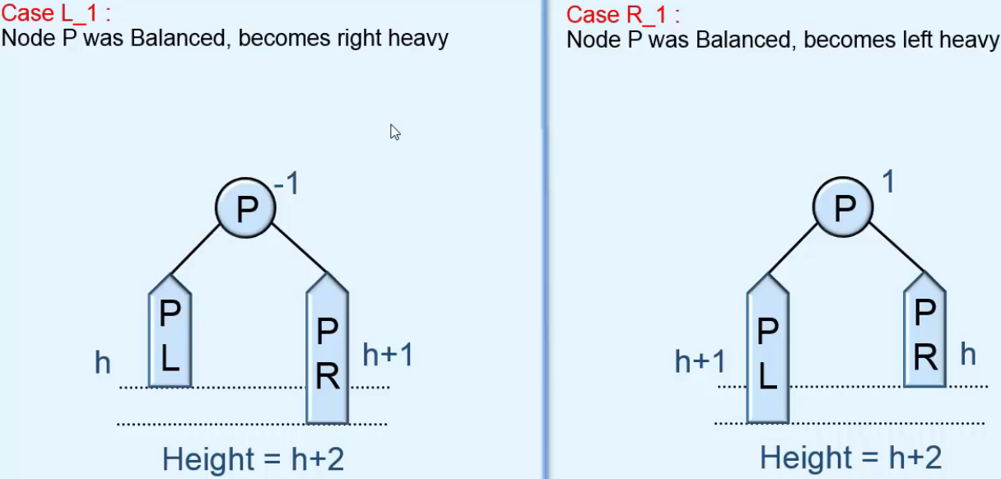  
* **Height of the subtree rooted at node P doesn’t change after deletion and so the balance factors of the ancestor nodes of this node will remain unchanged, set shorter = false, stop checking**.

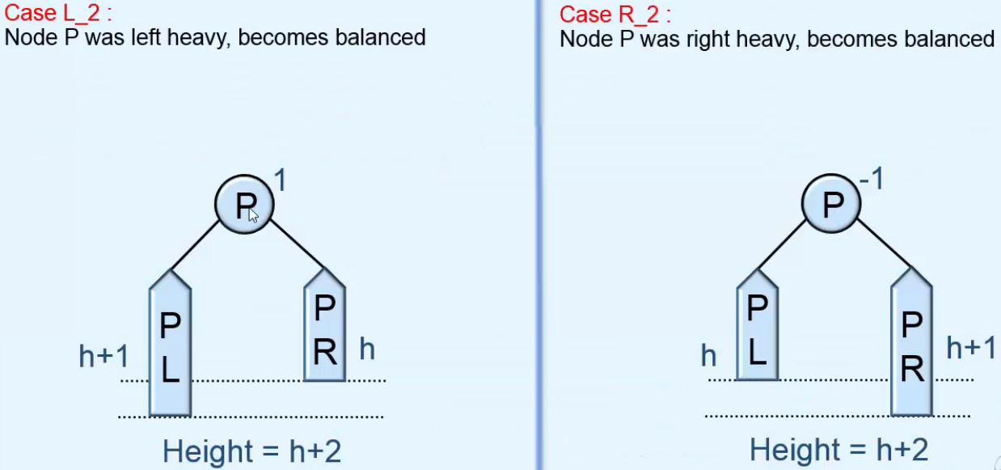  
* **Height of the subtree rooted at node P decreased after deletion and so the balance factors of the ancestor nodes of this node will change, shorter remains true, keep checking**.

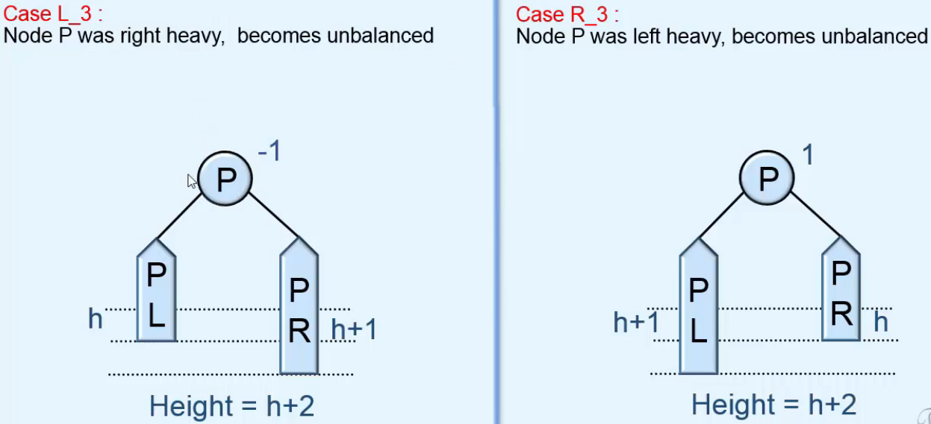  
* **In Insertion we explored the subtree in which insertion was done**.  
* **In Deletion we explore the subtree other than the one in which the deletion was done**.  
* **Only the nodes on the path from the deleted one to the root can be affected**.  
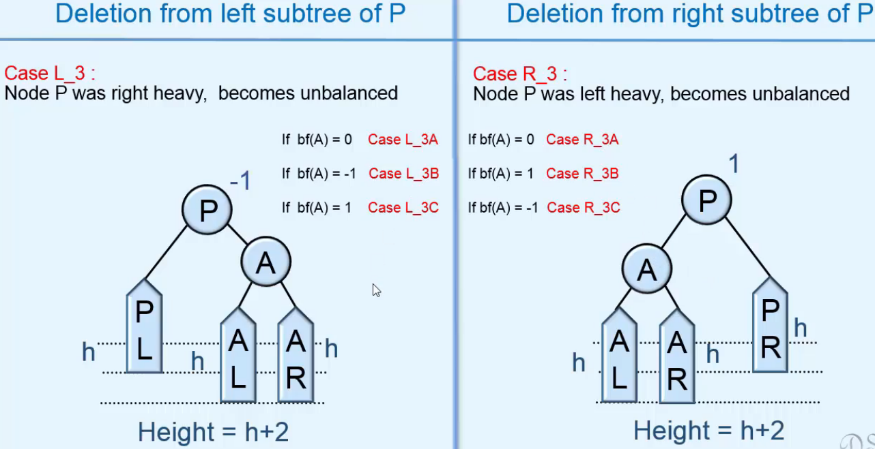

* **Let’s look at the 3 subcases**.  
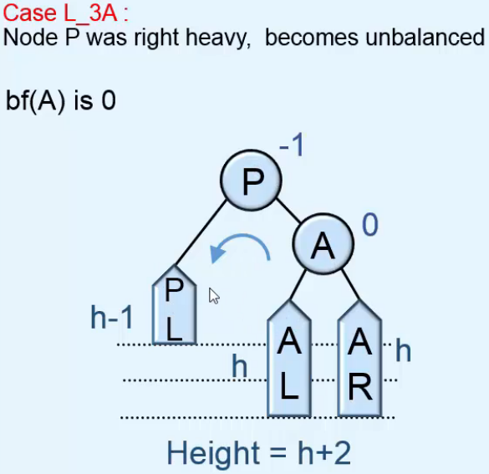 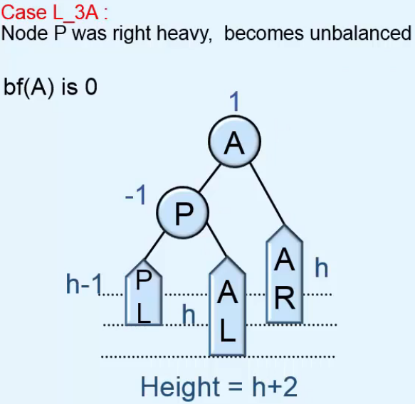  
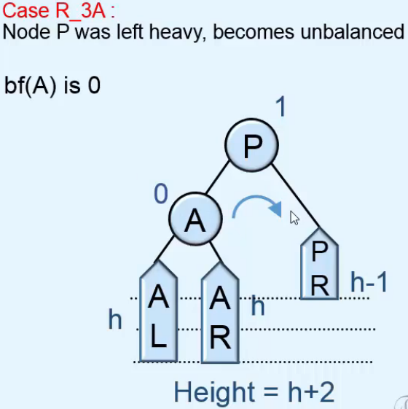 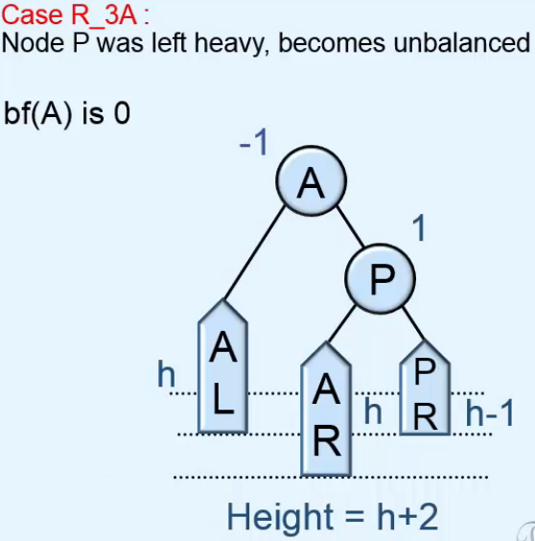  
* **Height remains the same => shorter = FALSE**.  
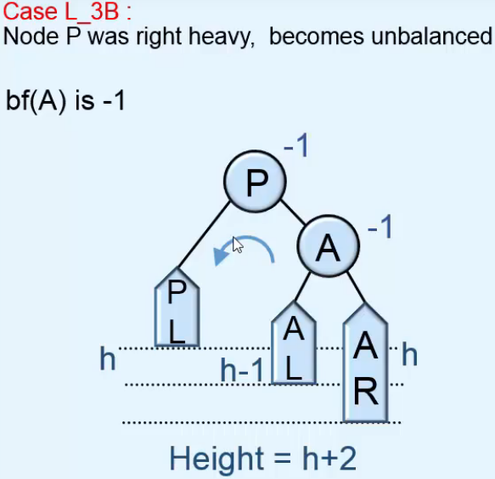 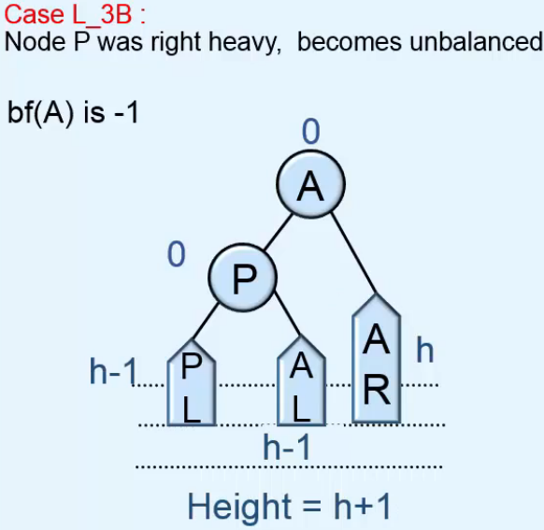  
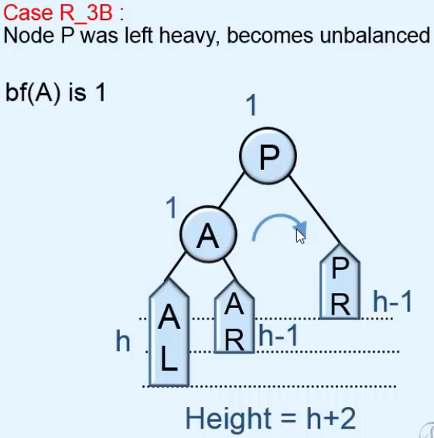 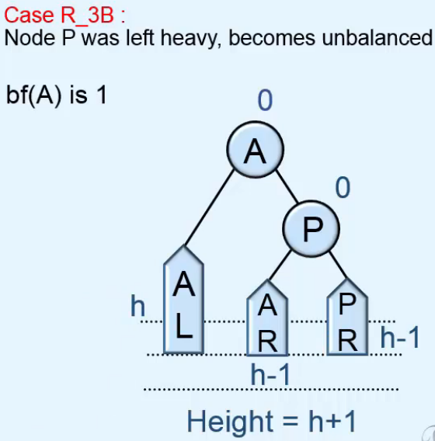  
* **Height decreased after deletion so we have to continue checking, shorter remains TRUE**.

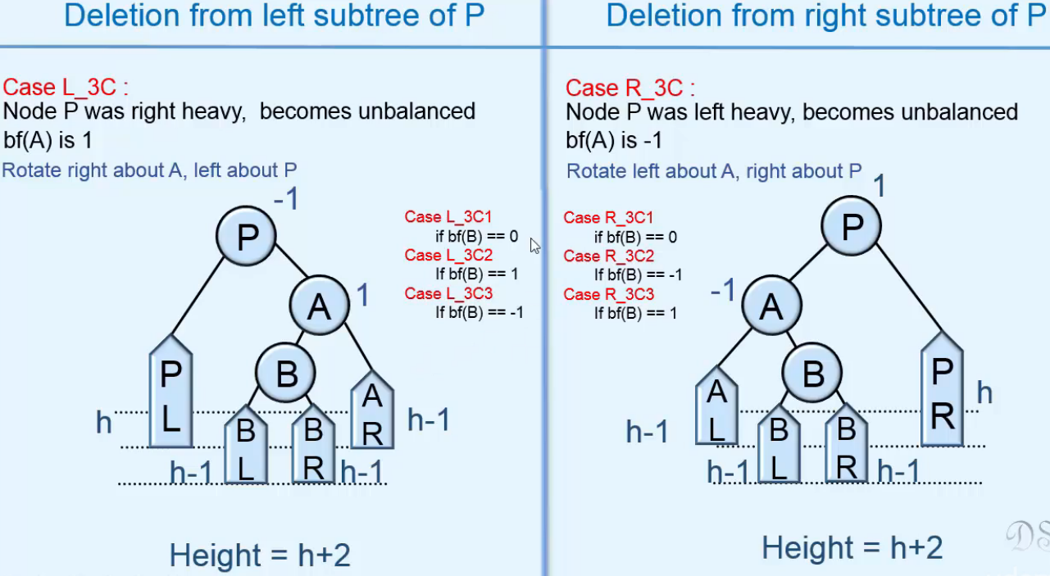  
**C1**  
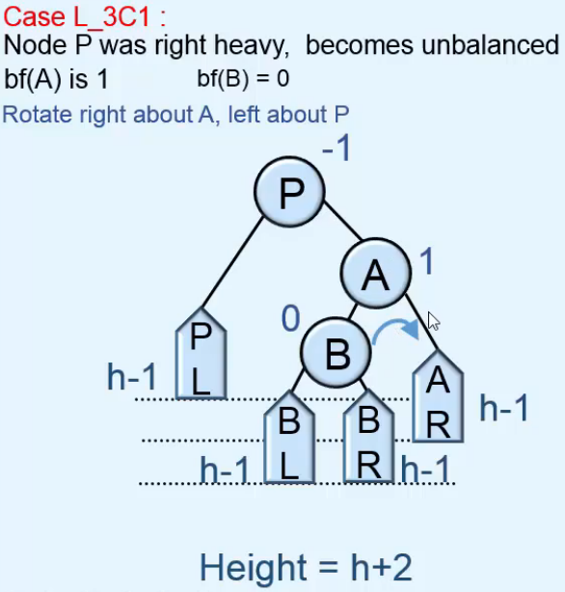 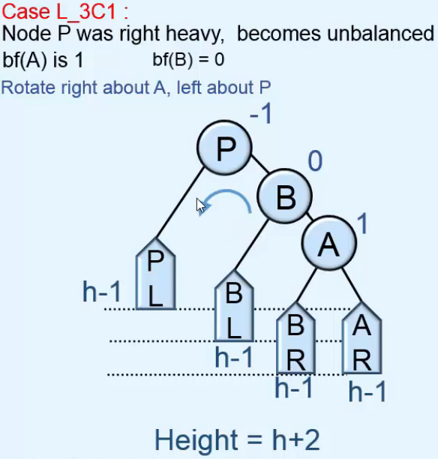 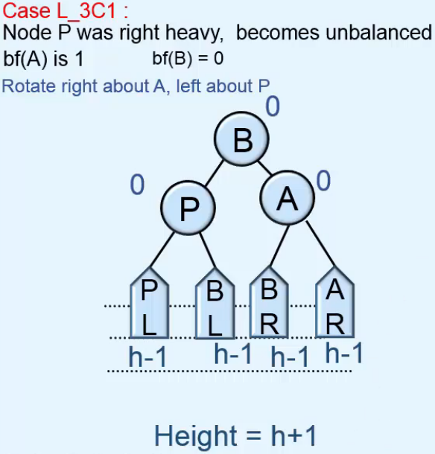  
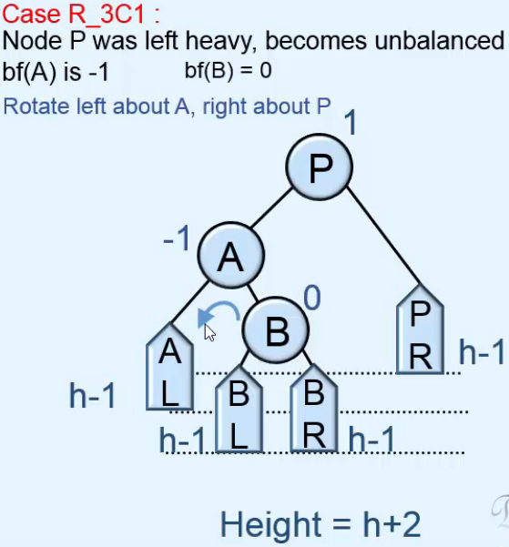 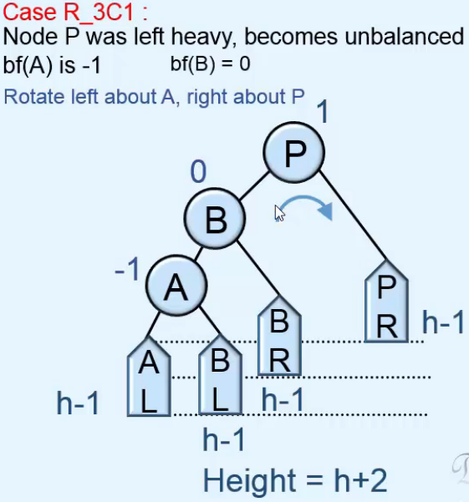 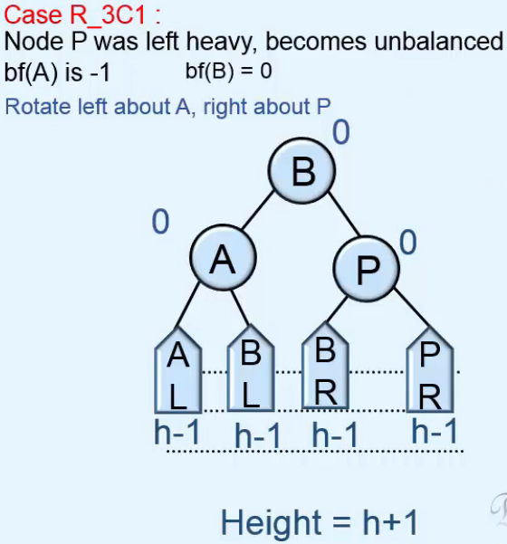  
* **Height decreased after deletion so we have to continue checking, shorter remains TRUE**.

**C2**  
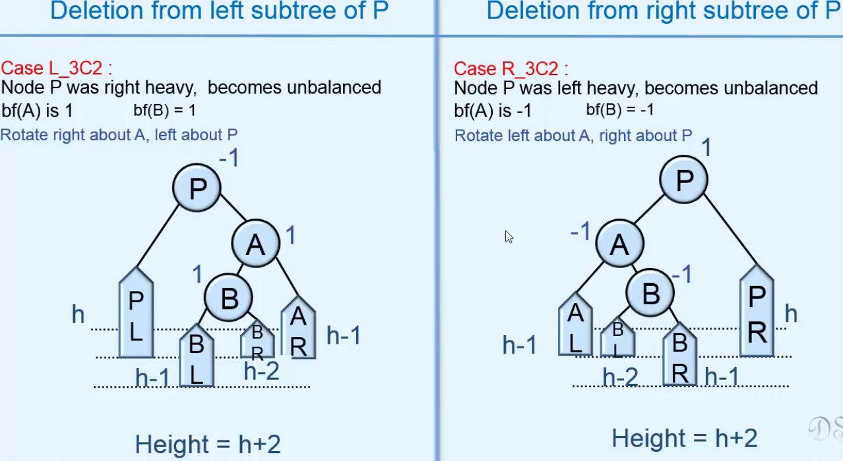  
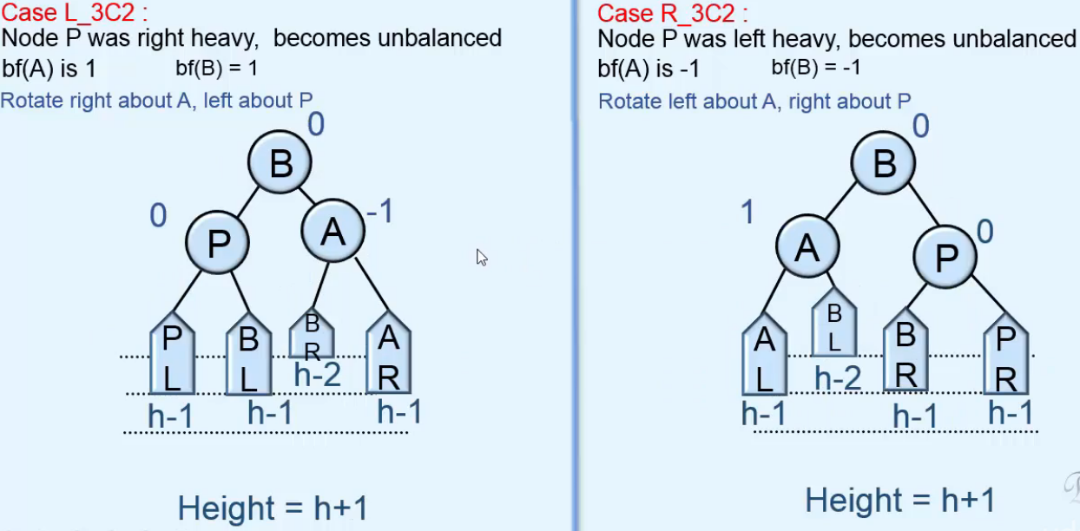  
**^ after deletion and rotation**.  
* **Height decreased after deletion so we have to continue checking, shorter remains TRUE**.

**C3**  
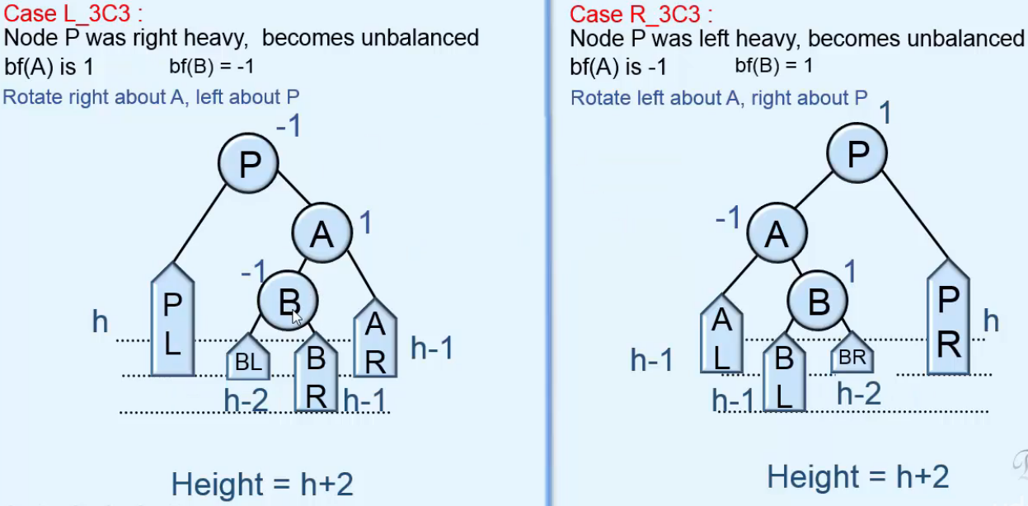  
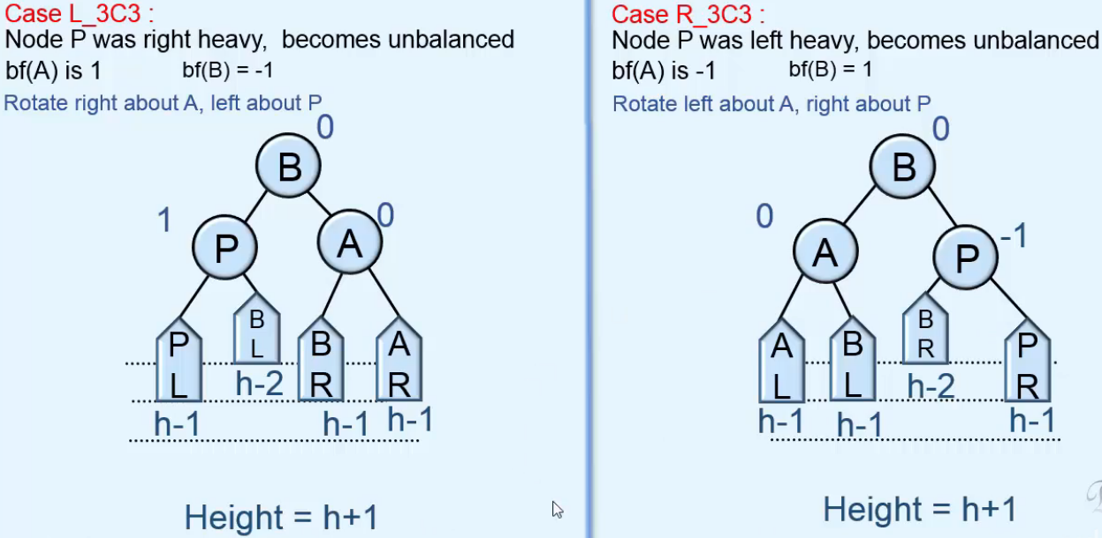  
**^ after deletion and rotation**.  
* **Height decreased after deletion so we have to continue checking, shorter remains TRUE**.

**Deletion in AVL Trees - 3**  
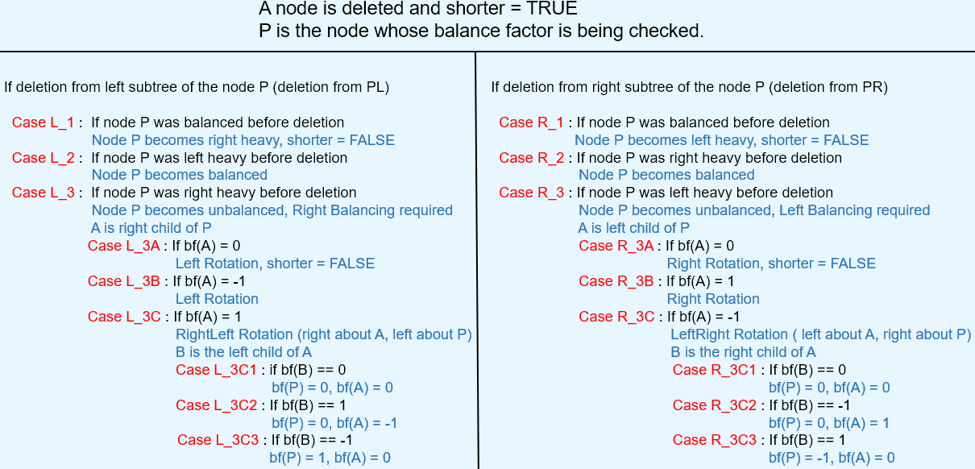  
* **Even after performing a rotation, you may have to proceed and check the balance factors of other nodes**.  
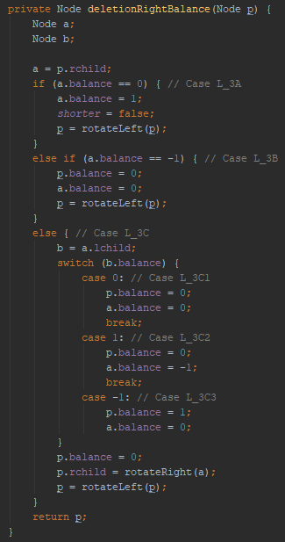 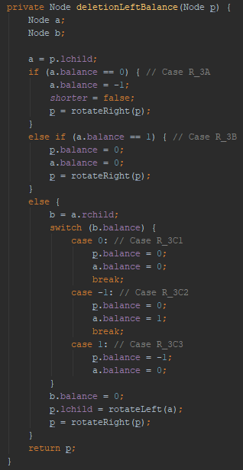

**Examples of Deletion in AVL Tree**  
